# Laboratory 6

**Data Dictionary and Control Flow Diagram**

1. **Introduction and Purpose of Experiment**

Students will apply object oriented analysis and design for the given scenario for object decomposition

1. **Aim and Objectives**

**Aim:** To construct a UML class diagram for a given system and identify the class members and determine their relationships

**Objectives:** At the end of this lab, the student will be able to

* + Identify the main members of the family
  + Identify how they are related to each other
  + Find the characteristics of each family member
  + Determine relations among family members
  + Decide the inheritance of personal traits and characters

1. **Experimental Procedure**

* Work in teams of students
* Each team should read the problem statement and discuss the requirements as a group
* Each team will then create and confirm the design and document the design in an software design specifications document
* Each individual will then write their lab manual, documenting their observations

1. **Presentation of Results**

**Data Dictionary:**

|  |  |
| --- | --- |
| **NAME:** | Language Interface |
| **ALIASES:** | Language translation |
| **WHERE/HOW USED:** | Whenever customer wants to change the language in the table assistant, he can use this feature in the options given by the assistant |
| **DESCRIPTION:** | This language interface is the software which can be capable of changing the language of the interface in the digital assistant. |
| **FORMAT:** | String |

|  |  |
| --- | --- |
| **NAME:** | **Login details** |
| **ALIASES:** | **Authorization details** |
| **WHERE/HOW USED:** | **Whenever manager, cashier wants to login to the hotel account, he uses his/her username and password as the login details for the account** |
| **DESCRIPTION:** | **These are the authorized details of one’s person, to login to an account using his/her username and password.** |
| **FORMAT:** | **Alphanumeric data** |

|  |  |
| --- | --- |
| **NAME:** | Order details |
| **ALIASES:** | Item selection details |
| **WHERE/HOW USED:** | The order details are given to the chef, through the digital assistant sent by the customer. |
| **DESCRIPTION:** | The order details consists of the food items selected by the customer from the menu given by the table assistant. |
| **FORMAT:** | Alphanumeric data |

|  |  |
| --- | --- |
| **NAME:** | Bank Details |
| **ALIASES:** | Payment details |
| **WHERE/HOW USED:** | Whenever the customer wants to pay the bill of the items through online payment, he needs to submit his/her bank details for the payment |
| **DESCRIPTION:** | The bank details consists of his/her account number/card details, account holder’s name, validity, cvv etc. |
| **FORMAT:** | Alphanumeric data |

|  |  |
| --- | --- |
| **NAME:** | Feedback details |
| **ALIASES:** | Remarks |
| **WHERE/HOW USED:** | Whenever the customer completes his payment, he needs to submit his feedback of the hotel management either through digital assistant or through the cashier. |
| **DESCRIPTION:** | The feedback details are the remarks of hotel management given by the customer. |
| **FORMAT:** | Alphanumeric data |

**Control Flow Diagram:**

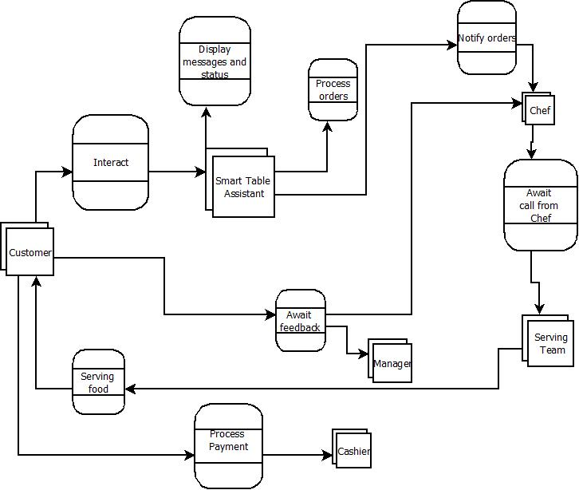

1. **Analysis and Discussions**
2. **Conclusions**
3. **Comments**

**1. Limitations of Experiments**

**2. Limitations of Results**

**3. Learning happened**

**4. Recommendations**

|  |  |  |
| --- | --- | --- |
| **Component** | **Max Marks** | **Marks Obtained** |
| **Viva** | **6** |  |
| **Results** | **7** |  |
| **Documentation** | **7** |  |
| **Total** | **20** |  |